Supplementary File
List of Abbreviations
CO - Cardiac Output
Ea - arterial elastance
EDPVR - End-diastolic pressure volume relation
EF - ejection fraction
EHC - endovascular hemorrhage control
ESP - End-systolic pressures
ESPVR - End-systolic pressure volume relation
ESV - End-systolic volumes
EVAC - Endovascular variable aortic control
HR - Heart Rate
IVCO - Inferior vena cava occlusion
MAP - mean arterial pressure
NCTH - non-compressible truncal hemorrhage
P-V - Pressure-volume
REBOA - Resuscitative Endovascular Balloon of the Aorta
SV - Stroke Volume
SW - Stroke Work

Supplemental Figure 1. Illustration of P-V loop analysis by quadrants. ) Four key events in the
cardiac cycle are defined by the pressure gradient (i.e., dP/dt max and dP/dt min). i) Aortic valve
opening (turquoise), ii) End of systole (red), iii) End of isovolumetric relaxation (pink), and iv) end
of diastole (purple), B) Four key elements of the cardiac cycle derived from the timepoints defined in
Figure 1A. This includes the i) Ejection Phase (blue), ii) Isovolumetric Relaxation (red), iii) Left Ventricular filling (purple) and iv) Isovolumetric contraction (turquoise).
A.  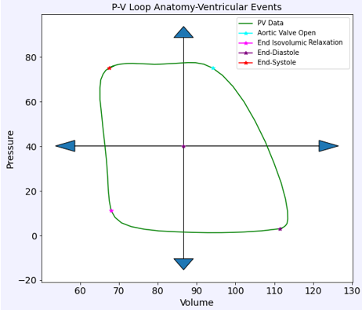 | B.  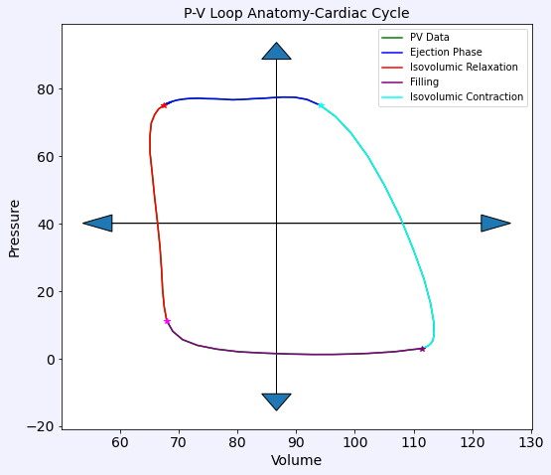

Supplemental Figure 2. Sample Algorithm Results. A) Sample of Pre-Screening Report, B) Sample Parameter Histogram, C) Sample Parameter Beat-to-Beat Report, D) Sample Parameter Time Variation Report
A.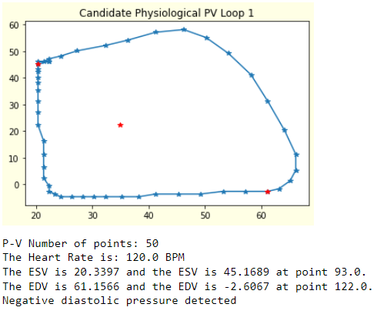 | B.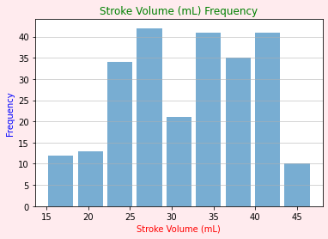
C.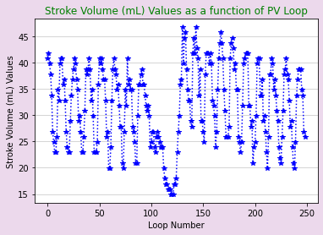 | D.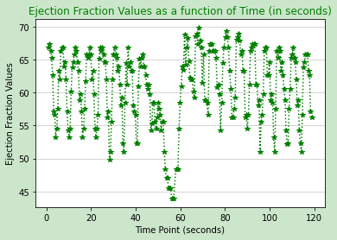

Supplemental Table 1. Load-Independent Curve Fits. To address varying curve fits for the EDPVR and ESPVR our code has incorporated six possible curve fits for both. However, for the purpose of the manuscript we focused on the linear curve fit for ESPVR as described the methods.

EDPVR Curve Fits | ESPVR Curve Fits
$$P=A+Be^{αV}$$  $$P=Ce^{βV}$$  $$P=D+aV^{3}$$  $$P=a_{0}+a_{1}V+a_{2}V^{2}+a_{3}V^{3}$$  $$P=b+cV^{γ}$$  $$P=dV^{δ}$$ | $$P=a_{1}V+a_{0}$$  $$P=a_{1}V+a_{0}, where P\left(V_{0,lin}\right)=0$$  $$P=a_{2}V^{2}+a_{2}V+a_{0}$$  $$P=a_{2}V^{2}+a_{2}V+a_{0}, where P\left(V_{0,quad}\right)=0$$  $$P=\ln\left(\frac{V}{V_{0}}\right){\left(α+βV\right)}^{-1}$$  $$P=\ln\left(\frac{V}{V_{0}}\right){\left(α+βV\right)}^{-1}, where P\left(V_{0,log}\right)=0$$

Supplemental Figure 3. Representative ensemble average P-V loops at baseline. A) Pre-IVCO, B) During-IVCO, C) Post-IVCO and D) Cumulative P-V loops are illustrated. One minute of data was extracted and processed to calculate the ensemble average, except for during IVCO phases, where we had ~15 seconds of data. The ensemble average provides a singular representation of the left ventricular P-V relationship during each phase as opposed to selecting an individual loop which may have been impacted by a respiration artifact, allowing for comparison of P-V events pre-, during- and post-IVCO to be reasonably compared. As seen below, during IVCO, the P-V loops experience a reduction in preload, which translates to reduced pressure and volumes and thus a relatively smaller “loop” size. Post-IVCO the P-V loop returns to the pre-IVCO state. This shift occurs consistently throughout our experiment.

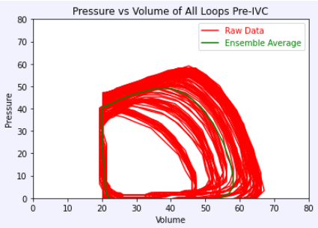  A) Ensemble average super-imposed to data sampled Pre-IVCO | 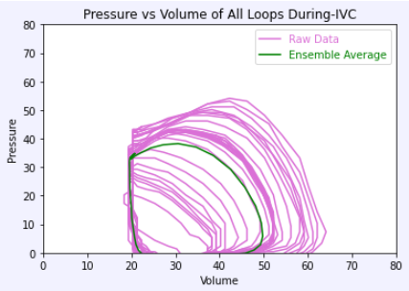  B) Ensemble average super-imposed to data sample during IVCO
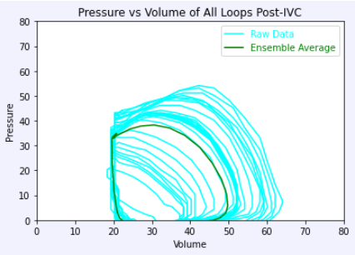  C) Ensemble average super-imposed to data sampled Post-IVCO | 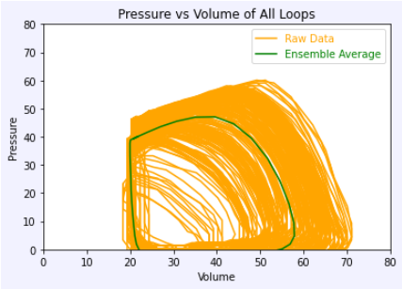  D) Ensemble average super-imposed to data sampled Pre-, During- and Post-IVCO

Supplemental Table 2. Summary Curve Fit Parameters for EDPVR During IVCO. Mean and standard deviations for each parameter at baseline (T0), end of hemorrhage (T30) and at the end of intervention (T74) are reported. A least squares regression for best fit was used to determine D and a curve fit parameters.

EDPVR
$$P_{ed}=D+a{V_{ed}}^{3}$$
Time Point | Group | D  mmHg | a  mmHg/${mL}^{3}$
T0  Baseline | Control | 0.54±4.57 | 9.44E-6 ± 5.92E-6
 | REBOA | 3.09±4.07 | 3.28E-6 ± 5.10E-6
 | EVAC | 3.41±5.89 | -2.49E-6 ± 1.09E-6
T30  End of Hemorrhage | Control | 2.46±4.47 | 2.69E-5 ± 3.06E-5
 | REBOA | 4.4±0.47 | 1.05E-5 ± 1.58E-5
 | EVAC | 1.68±2.07 | 0.47E-5 ± 1.01E-5
T74  End of Intervention | Control | 1.82±1.41 | 6.24E-6 ± 3.62E-6
 | REBOA | 1.1±2.94 | 9.78E-6 ± 2.89E-6
 | EVAC | 3.55±4.49 | 2.77E-6 ± 6.38E-6

Supplemental Table 3A. Summary of Control Group Cardiac Metrics. Mean and standard deviations are reported at each time point and pre-IVCO, during IVCO and post-IVCO.

 | T0  Pre-IVCO | T0 During IVCO | T0  Post-IVCO | T30  Pre- IVCO | T30  During IVCO | T30  Post- IVCO | T74  Pre- IVCO | T74  During IVCO | T74  Post- IVCO
Stroke Work (mmHg*mL) | 3300.8 ± 651.9 | 1973.6 ± 681.3 | 3190.5 ± 619.8 | 1451.5 ± 636.3 | 742.5 ± 344.3 | 1686.3 ± 718.4 | 4226.4 ± 801.8 | 2107.8 ± 653.2 | 4152.3 ± 1103.7
Stroke Volume (mL) | 44.6 ± 10.8 | 35.5 ± 10.1 | 43.7 ± 11.8 | 38.6 ± 10.9 | 25.3 ± 7.6 | 41.1 ± 12.2 | 55.9 ± 9.2 | 41.8 ± 4.4 | 51.7 ± 11.0
Ejection Fraction (%) | 42.2 ± 10.9 | 47.6 ± 13.7 | 41.9 ± 12.1 | 59.0 ± 10.6 | 49.5 ± 8.5 | 61.7 ± 9.7 | 53.8 ± 5.9 | 54.4 ± 6.5 | 51.9 ± 8.0
Heart Rate (bpm) | 91.3 ± 19.5 | 92.4 ± 19.6 | 91.9 ± 20.2 | 127.7 ± 34.6 | 123.9 ± 29.6 | 119.5 ± 26.0 | 136.5 ± 19.9 | 136.1 ± 21.6 | 133.0 ± 24.1
Cardiac Output (L/min) | 4.0 ± 1.1 | 3.3 ± 1.1 | 4.0 ± 1.2 | 5.1 ± 2.5 | 3.3 ± 1.7 | 5.1 ± 2.4 | 7.7 ± 1.9 | 5.7 ± 0.9 | 6.9 ± 1.9
Arterial Elastance (mmHg/mL) | 1.8 ± 0.5 | 1.7 ± 0.4 | 1.9 ± 0.8 | 1.1 ± 0.4 | 1.4 ± 0.4 | 1.0 ± 0.3 | 1.4 ± 0.5 | 1.4 ± 0.4 | 1.5 ± 0.5
ESV (mL) | 63.3 ± 17.7 | 42.9 ± 20.4 | 63.0 ± 19.2 | 26.6 ± 6.4 | 25.5 ± 5.8 | 25.2 ± 5.5 | 48.4 ± 5.9 | 34.6 ± 8.3 | 48.6 ± 9.5
ESP (mmHg) | 74.9 ± 7.5 | 56.7 ± 5.7 | 72.7 ± 8.0 | 37.4 ± 7.7 | 32.2 ± 5.4 | 39.0 ± 7.7 | 71.6 ± 15.8 | 53.4 ± 10.5 | 72.9 ± 14.5
EDV (mL) | 107.9 ± 13.1 | 78.3 ± 22.2 | 106.7 ± 13.7 | 65.2 ± 11.1 | 50.7 ± 10.5 | 66.3 ± 13.4 | 104.3 ± 9.3 | 76.4 ± 8.8 | 100.3 ± 11.5
EDP (mmHg) | 6.7 ± 2.3 | 4.8 ± 3.6 | 6.4 ± 2.7 | 4.4 ± 2 | 3.8 ± 2.4 | 3.2 ± 2.4 | 7.2 ± 2.0 | 5.6 ± 0.8 | 4.2 ± 1.6

Supplemental Table 3B. Summary of REBOA Group Cardiac Metrics. Mean and standard deviations are reported at each time point and pre-IVCO, during IVCO and post-IVCO.

 | T0  Pre-IVCO | T0 During IVCO | T0  Post-IVCO | T30  Pre- IVCO | T30  During IVCO | T30  Post- IVCO | T74  Pre- IVCO | T74  During IVCO | T74  Post- IVCO
Stroke Work (mmHg*mL) | 3647.9 ± 1097.7 | 1763.9 ± 636.4 | 3447.8 ± 1081.4 | 1823.5 ± 460.3 | 414.3 ± 151.2 | 1908.1 ± 423.9 | 9327.8 ± 3237.8 | 5680.8 ± 4349.5 | 8785.4 ± 3016.3
Stroke Volume (mL) | 50.3 ± 20.7 | 36.1 ± 11.7 | 51.7 ± 18.7 | 46.2 ± 14.1 | 22.8 ± 5.1 | 47.9 ± 14.3 | 59.4 ± 33.2 | 49.2 ± 30.9 | 61.3 ± 29.6
Ejection Fraction (%) | 41.8 ± 9.6 | 45.2 ± 8.7 | 45.6 ± 7.4 | 60.2 ± 8.4 | 39.5 ± 2.8 | 62.5 ± 5.5 | 45.2 ± 13.4 | 51.3 ± 14.9 | 49.5 ± 11.0
Heart Rate (bpm) | 89.8 ± 14.6 | 92.9 ± 19.5 | 88.9 ± 13.5 | 117.5 ± 23.3 | 113.2 ± 19.2 | 111.2 ± 22.3 | 163.4 ± 16.5 | 154.9 ± 34.1 | 157.6 ± 17.4
Cardiac Output (L/min) | 4.8 ± 2.9 | 3.5 ± 1.7 | 4.8 ± 2.6 | 5.5 ± 2.3 | 2.6 ± 0.9 | 5.4 ± 2.2 | 9.7 ± 5.6 | 7.8 ± 5.4 | 9.6 ± 4.8
Arterial Elastance (mmHg/mL) | 1.7 ± 0.6 | 1.7 ± 0.6 | 1.4 ± 0.4 | 1.0 ± 0.4 | 1.4 ± 0.8 | 0.9 ± 0.4 | 3.9 ± 2.0 | 2.7 ± 1.1 | 3.0 ± 1.7
ESV (mL) | 68.4 ± 15.7 | 44.3 ± 7.1 | 61.7 ± 17.0 | 30.9 ± 11.0 | 35.6 ± 12.2 | 29.0 ± 9.7 | 68.9 ± 21.1 | 43.2 ± 10.9 | 60.6 ± 14.5
ESP (mmHg) | 72.1 ± 3.7 | 55.3 ± 8.8 | 66.2 ± 7.0 | 39.3 ± 7.8 | 28.6 ± 7.5 | 39.1 ± 8.7 | 173.8 ± 18.9 | 108.9 ± 42.2 | 143.0 ± 28.8
EDV (mL) | 118.7 ± 27.0 | 80.4 ± 11.8 | 113.4 ± 29.6 | 77.1 ± 21.3 | 58.4 ± 17.3 | 76.9 ± 22.0 | 128.3 ± 43.3 | 92.4 ± 33.7 | 121.9 ± 36.1
EDP (mmHg) | 6.6 ± 3.5 | 4.8 ± 3.7 | 6.1 ± 2.8 | 2.4 ± 1.8 | 3.5 ± 2.2 | 2.3 ± 1.6 | 6.4 ± 1.6 | 5.3 ± 2.8 | 5.7 ± 1.9

Supplemental Table 3C. Summary of EVAC Group Cardiac Metrics. Mean and standard deviations are reported at each time point and pre-IVCO, during IVCO and post-IVCO.

 | T0  Pre-IVCO | T0 During IVCO | T0  Post-IVCO | T30  Pre- IVCO | T30  During IVCO | T30  Post- IVCO | T74  Pre- IVCO | T74  During IVCO | T74  Post- IVCO
Stroke Work (mmHg*mL) | 3201.4 ± 744.0 | 1994.0 ± 754.2 | 3132.3 ± 792.3 | 1840.7 ± 342.1 | 1236.4 ± 449.1 | 2530.2 ± 641.4 | 4771.3 ± 870.8 | 3017.5 ± 1454.4 | 4621.4 ± 871.9
Stroke Volume (mL) | 42.9 ± 14.6 | 24.8 ± 5.1 | 42.7 ± 15.2 | 39.2 ± 5.8 | 29.5 ± 5.4 | 43.6 ± 9.3 | 34.2 ± 0.9 | 28.0 ± 4.7 | 34.3 ± 4.4
Ejection Fraction (%) | 44.5 ± 12.9 | 38.5 ± 12.0 | 44.9 ± 13.8 | 62.2 ± 8.0 | 55.2 ± 10 | 64.3 ± 7.0 | 39.0 ± 6.08 | 41.1 ± 8.3 | 40.8 ± 7.7
Heart Rate (bpm) | 88.5 ± 18.9 | 86.0 ± 22.2 | 85.5 ± 13.4 | 135.4 ± 31.1 | 133.7 ± 29.4 | 118.6 ± 21.8 | 135.05 ± 27.78 | 130.2 ± 30.4 | 135.4 ± 26.4
Cardiac Output (L/min) | 3.8 ± 1.5 | 2.1 ± 0.4 | 3.7 ± 1.5 | 5.4 ± 1.8 | 3.9 ± 0.8 | 5.3 ± 1.8 | 4.6 ± 0.9 | 3.6 ± 0.9 | 4.6 ± 1.0
Arterial Elastance (mmHg/mL) | 2.0 ± 0.8 | 2.9 ± 0.8 | 2.0 ± 0.8 | 1.2 ± 0.3 | 1.5 ± 0.3 | 1.3 ± 0.4 | 4.07 ± 0.69 | 3.6 ± 0.8 | 4.0 ± 1.3
ESV (mL) | 55.3 ± 21.4 | 42.3 ± 17.9 | 54.2 ± 22.0 | 24.8 ± 8.7 | 24.2 ± 7.7 | 24.8 ± 8.1 | 55.65 ± 15.96 | 41.7 ± 11.1 | 51.9 ± 16.4
ESP (mmHg) | 76.1 ± 5.1 | 64.8 ± 11.5 | 73.4 ± 7.5 | 46.7 ± 6.5 | 42.0 ± 7.3 | 53.4 ± 11.2 | 134.62 ± 22.43 | 99.3 ± 25.1 | 123.8 ± 21.4
EDV (mL) | 98.2 ± 22.8 | 67.1 ± 18.8 | 96.9 ± 22.4 | 64.0 ± 11.7 | 53.8 ± 7.8 | 68.4 ± 14.8 | 89.8 ± 15.69 | 69.7 ± 9.3 | 86.2 ± 16.4
EDP (mmHg) | 7.0 ± 3.4 | 4.5 ± 3.7 | 6.9 ± 3.5 | 5.1 ± 5.2 | 3.7 ± 4.2 | 2.9 ± 3.1 | 7.46 ± 4.04 | 5.1 ± 3.3 | 6.0 ± 4.6

